Project: | CONSTRUCTION OF WATER DISTRIBUTION NETWORKS FOR VILLAGES IN WILAYAT SAMAIL AND IZKI (AI  DAKHILIYAH GOVERNORATE) (DESIGN & BUILD)
Client: | Nama Water Services
Consultant: | Eptisa - AZD (JV)
Contractor: | Hunan Industrial Equipment Installation Co., Ltd. (HIEICO)

Inspection Team Members |  | Site Location | Date: 29-01-2026 | QHSE Site Walk No.12
1 | Engr. Hilal Al Khalili (Project Manager) – NWS | WS-01 Block 76 & 77 | QHSE Site Walk Findings:
2 | Muhammad Al Balushi (Project Manager) – EGE-AZD (JV) | WS-01 Block 76 & 77 | Non-Conformity: | Nil
3 | Ranjie Octavo (QA/QC Engineer) – EGE-AZD (JV) | WS-01 Block 76 & 77 | Quality Findings: | 2
4 | Robert de Guzman (Electrical Engineer) – EGE-AZD (JV) | WS-01 Block 76 & 77 | HSE Findings: | 6
5 | Qusai Al Wardi (Site Inspector) – EGE-AZD (JV) |  | Positive Findings: | 1
6 | Haitham Al Ruqaishi (HSE Engineer) – EGE-AZD (JV) |  | Total Findings: | 9
7 | Atta Asim (Site Engineer) – EGE-AZD (JV)
8 | Issa Al Maskari (Site Inspector) – EGE-AZD (JV)
9 | Muhammad Abdusalam (Site Inspector) – EGE-AZD (JV)
10 | Al Moatasim Al Abri (Site Inspector) – EGE-AZD (JV)
11 | Aqeel Shaik (Deputy Project Manager) – HIEICO
12 | Ahmed Al Hadhrami (HSE Manager) – HIEICO
13 | Majid Anwar (Construction Manager) – HIEICO
14 | Li Xueyong (Construction Manager) – HIEICO
15 | Mansoor Al Busaidi (HSE Engineer) – HIEICO
16 | Said Al Mazroei (QA/QC Engineer) – HIEICO
17 | Aldieh Guincoma (Sr. QA/QC Engineer) – HIEICO
18 | Ed Ranay (Site Engineer) – HIEICO
19 | Bashar (Site Engineer) – HIEICO

QHSE Site Walk Findings:
S/L No. | Description of Findings | Photo | Discipline | Remarks
1 | During site inspection, it was observed that the access bridge for the locals is in bad condition. Proper net covering to be provided around the bridge. | 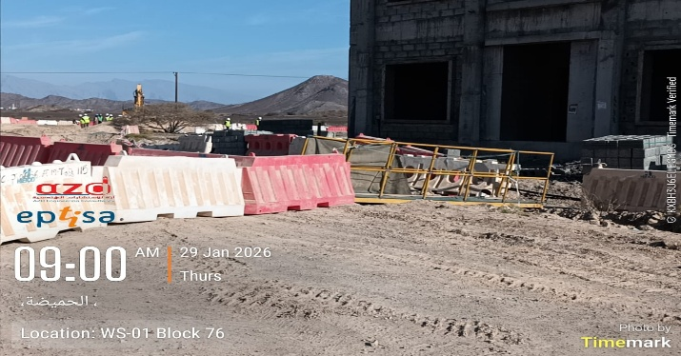 | HSE
2 | It was observed that wrong sign boards were provided at site. This is a repeated observation and Contractor is requested to take immediate action. | 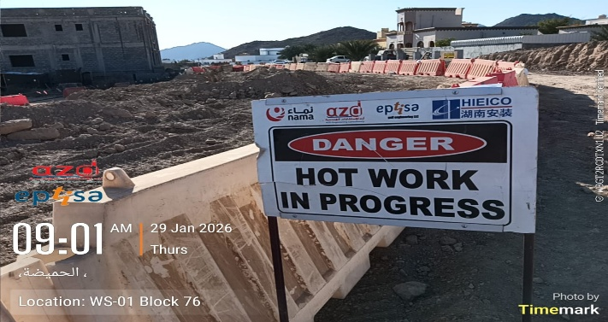 | HSE
3 | It was observed that the diesel filling was done immediately beside the road and without providing a flagman to alert oncoming traffic. | 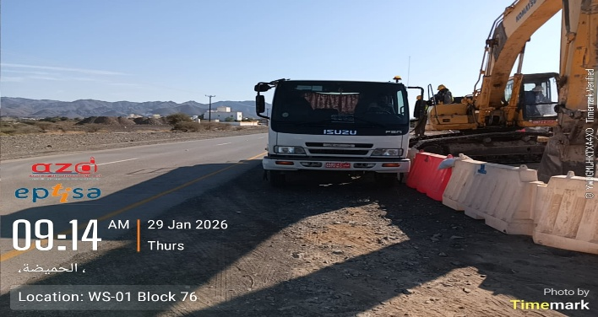 | HSE
4 | The approved method statement found at site contains controlled copy stamp and in good condition. | 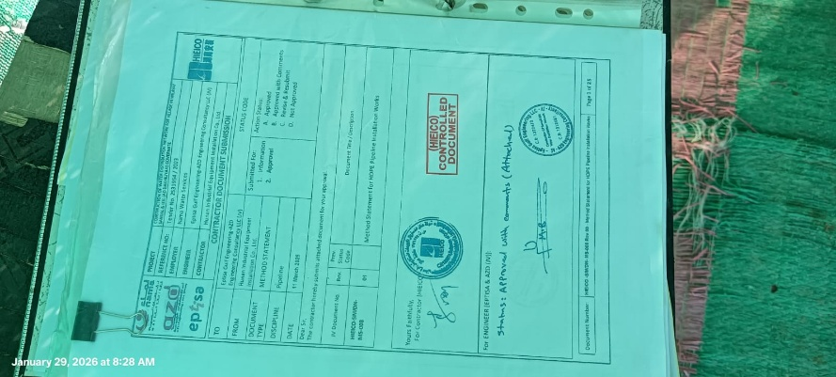 | Quality | Positive
5 | The approved method does not have a controlled copy stamp. This is a repeated observation and Contractor is requested to take immediate action. | 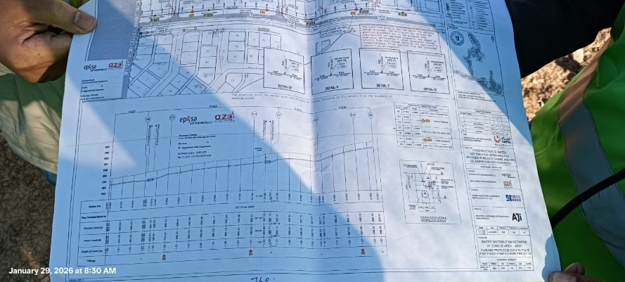 | Quality
6 | The site worker was observed not having a safety induction sticker on his hardhat. | 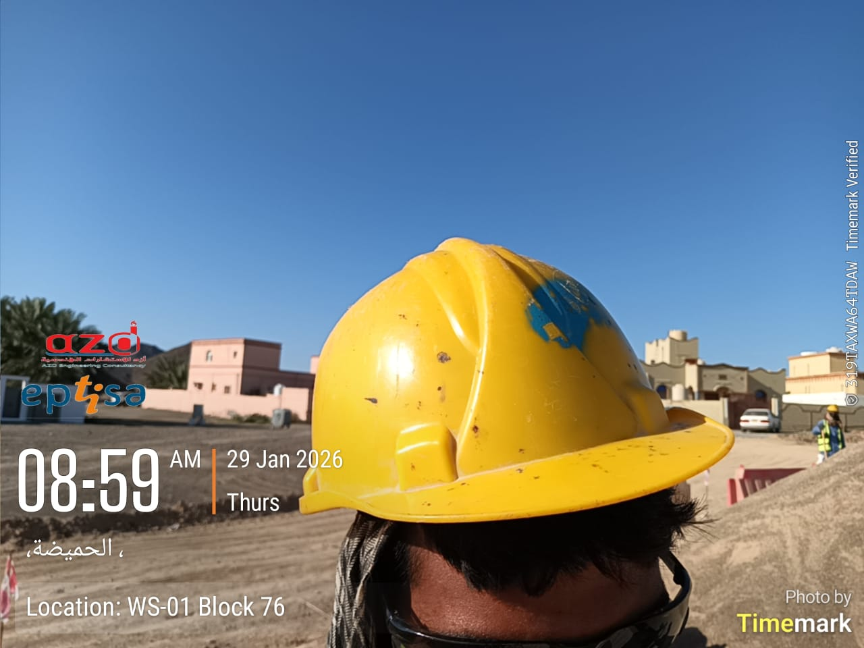 | HSE
7 | The barricades do not have sufficient number of sign boards and flicker lights. | 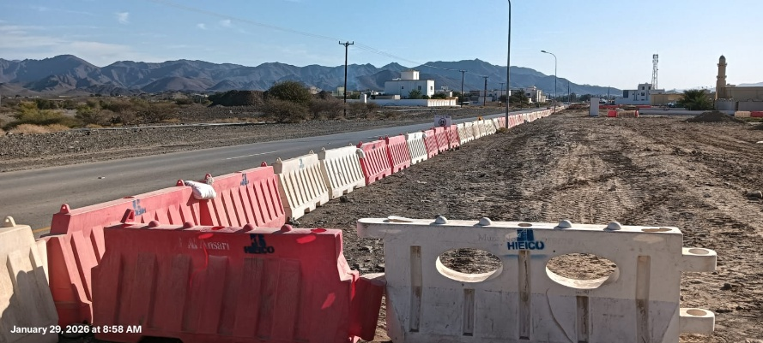 | HSE
8 | The site location does not have a nearby dedicated screen for backfilling purpose. Contractor mentioned that they installed the screen far from the residential area to avoid dust generation and complaint from house owners. But it was that the said screen was in very close proximity with the houses. | 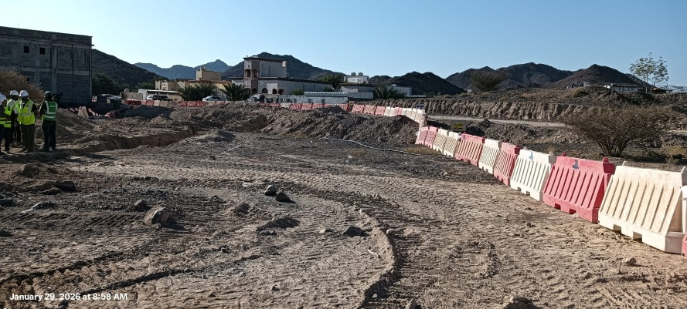 | Quality
8 |  | 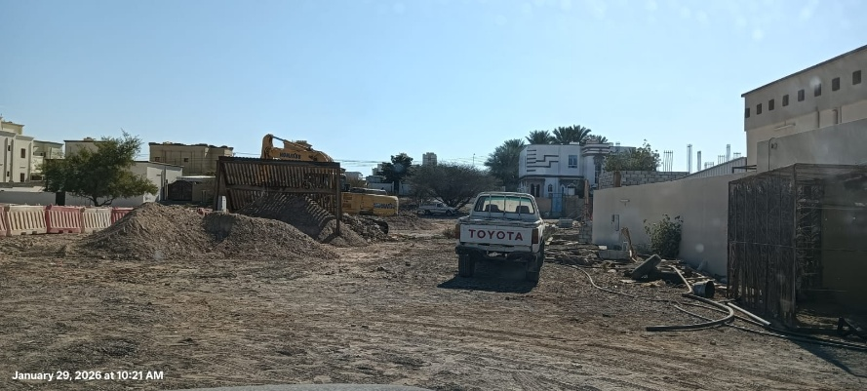 | HSE

 | For Quality Department | For HSE Department | Reviewed By | Approved By:
Name | Ranjie Octavo – QA/QC Engineer (EGE-AZD JV) | Haitham Al Ruqaishi – HSE Engineer (EGE-AZD JV) | Mr. John Kungu Njeri – (EGE-AZD JV) | Mr. Muhammad Al Balushi – (EGE-AZD JV)
Signature |  | 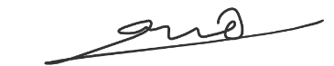
Date |   29/01/2026 | 29/01/2026

